ANIMALS
zvířata
MUST learn |  |  |  | MAY learn
 | dog | pes |  |  | wolf | vlk
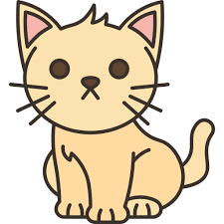 | cat | kočka |  |  | fox | liška
 | lion | lev |  |  | tiger | tygr
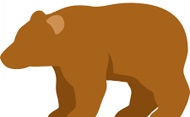 | bear | medvěd |  |  | rabbit | králík
 | bat | netopýr |  |  | hedgehog | ježek
 | mouse | myš |  |  | rat | krysa
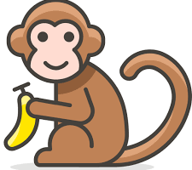 | monkey | opice |  | 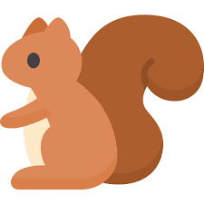 | squirrel | veverka
 | elephant | slon |  |  | hamster | křeček
 | dolphin | delfín |  |  | whale | velryba
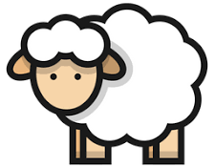 | sheep | ovce |  | 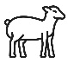 | lamb | jehně
 | pig | prase |  |  | rhino | nosorožec
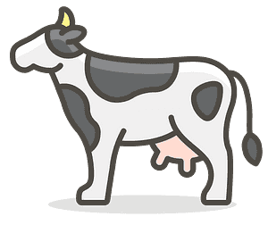 | cow | kráva |  | 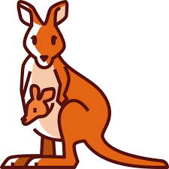 | kangaroo | klokan
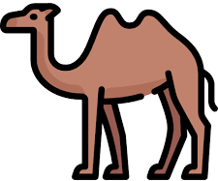 | camel | velbloud |  | 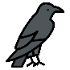 | raven | krkavec
 | horse | kůň |  | 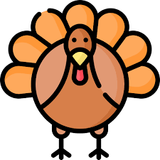 | turkey | krocan
 | zebra | zebra |  | 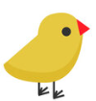 | chick | kuře
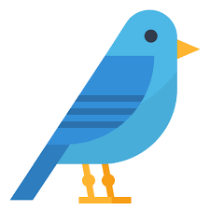 | bird | pták |  |  | penguin | tučňák
 | owl | sova |  |  | lizard | ještěrka
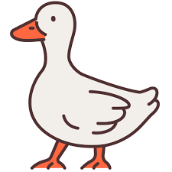 | duck | kachna |  |  | turtle | želva
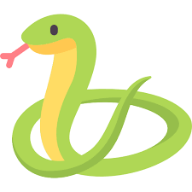 | snake | had |  | 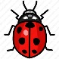 | ladybird | beruška
 | crocodile | krokodýl |  |  | dragonfly | vážka
 | frog | žába |  | 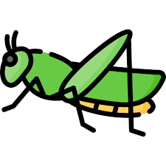 | grasshopper | koník / kobylka
 | fish | ryba |  | 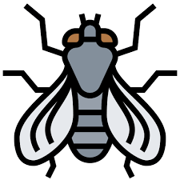 | fly | moucha
 | shark | žralok |  |  | bee | včela
 | butterfly | motýl |  | 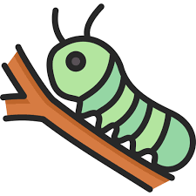 | caterpillar | housenka
 | crab | krab |  |  | worm | červ
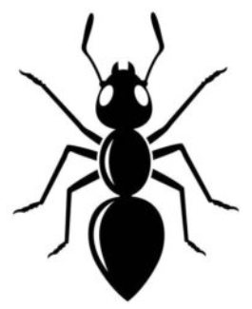 | ant | mravenec |  |  | octopus | chobotnice
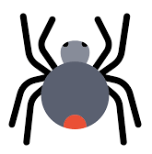 | spider | pavouk |  | 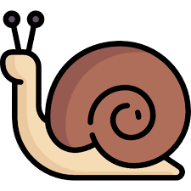 | snail | hlemýžď
The Ants and the Grasshopper

1. In the summer, the ants were a-working
Bringing food to their hill every day
While the grasshopper sang in the sunshine
On his fiddle, his song he did play
Fi-de-di, de-dah-doo, dah-de da-do
Fi-de-do, de-da-dee, de-da-day

2. I will sing all the while 'neath the sunshine
'Neath the moon, I will dance, I will play
In the autumn, the ants were still working
But the grasshopper still did not care
The ants asked, "Why don't you store food for winter?"
"When it's cold, you'll have no food to spare"
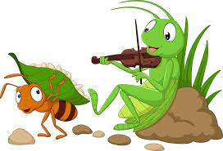
Fi-de-di…

3. Above us all, there will always be sunshine
And there always will be time to play
Time went by and along came the winter
And the wind gave a cold icy chill
Snow fell down and there was no more sunshine
So the grasshopper went up the hill
Fi-de-di…

4. I am cold, I am wet, I am hungry
And I'm sorry I played the days away
In the valley, he went to the anthill
He was cold and embarrassed and sad
But the ants told him that he was welcome
Then he thanked them and felt really glad
Fi-de-di…
And the grasshopper said, "In future seasons
Work comes first, then I'll have time to play"

Five Little Ducks

1. Five little ducks went out one day.
Over the hill and far away.
Mother duck said, “Quack, quack, quack, quack.”
But only four little ducks came back.
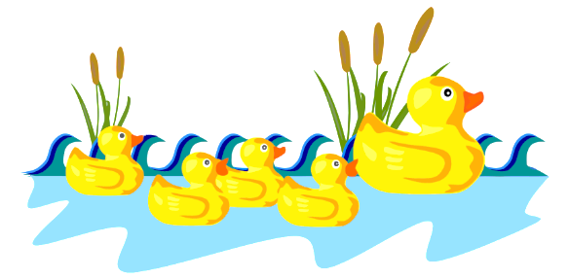
2. Four…
3. Thre…
4. Two…

5. One little duck went out one day.
Over the hill and far away.
Mother duck said, “Quack, quack, quack, quack.”
But none of the five little ducks came back.

6. Sad mother duck went out one day.
Over the hill and far away.
Mother duck said, “Quack, quack, quack, quack.”
And all of five little ducks came back.

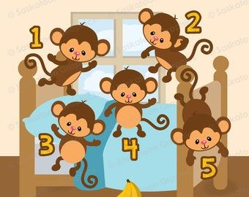
Five Little Monkeys

1. Five little monkeys jumping on the bed.
One fell off and bumped his head.
Mama called the doctor and the doctor said,
“No more monkeys jumping on the bed!”
2. Four…
3. Three…
4. Two…
5. One

