**Do you have blue eyes?** *Máš modré oči?*

**I have blue eyes.** *Mám modré oči.*

**I don’t have brown eyes.** *Nemám hnědé oči.*

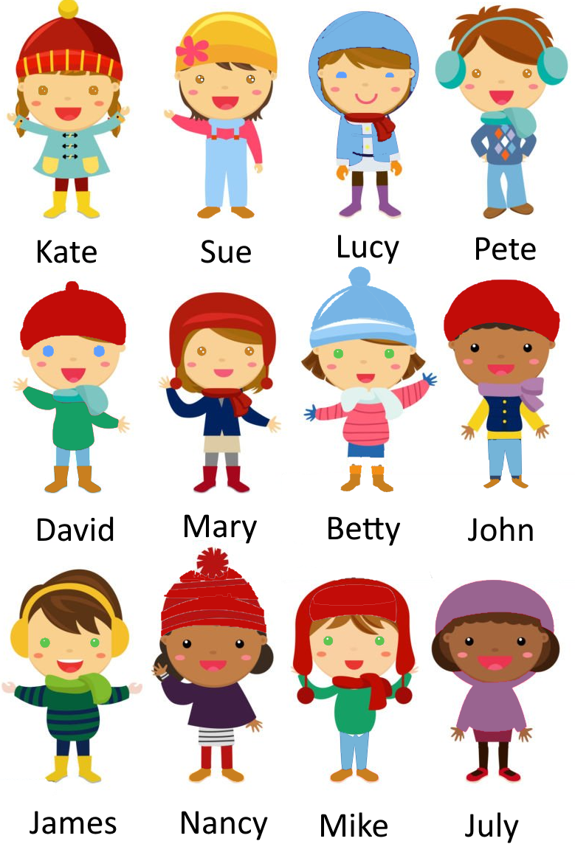

**It has four legs.** *Má čtyři nohy.*

**It is blue.** *Je modrý.*

|  |  |  |  |
| --- | --- | --- | --- |
| clown icon, fish icon  fish | C:\Users\ZŠ Líšnice\AppData\Local\Microsoft\Windows\INetCache\Content.MSO\406A12F9.tmp  sheep | C:\Users\ZŠ Líšnice\AppData\Local\Microsoft\Windows\INetCache\Content.MSO\2A69686F.tmp  dog | C:\Users\ZŠ Líšnice\AppData\Local\Microsoft\Windows\INetCache\Content.MSO\B27F3B55.tmp  lion |
| C:\Users\ZŠ Líšnice\AppData\Local\Microsoft\Windows\INetCache\Content.MSO\2D021D2B.tmp  snake | C:\Users\ZŠ Líšnice\AppData\Local\Microsoft\Windows\INetCache\Content.MSO\216C7E54.tmp  spider | Hlava krávy emoji klipart. Zdarma ke stažení transparentní .PNG | Creazilla  cow | C:\Users\ZŠ Líšnice\AppData\Local\Microsoft\Windows\INetCache\Content.MSO\5FBD6BE3.tmp  elephant |
| C:\Users\ZŠ Líšnice\AppData\Local\Microsoft\Windows\INetCache\Content.MSO\27836BD6.tmp  crab | C:\Users\ZŠ Líšnice\AppData\Local\Microsoft\Windows\INetCache\Content.MSO\3C7EFB82.tmp  monkey | C:\Users\ZŠ Líšnice\AppData\Local\Microsoft\Windows\INetCache\Content.MSO\44C026E0.tmp  shark | C:\Users\ZŠ Líšnice\AppData\Local\Microsoft\Windows\INetCache\Content.MSO\11EB8FEE.tmp  cat |
| C:\Users\ZŠ Líšnice\AppData\Local\Microsoft\Windows\INetCache\Content.MSO\62C9C573.tmp  penguin | File:Blue Butterfly Icon.png - Wikipedia  butterfly | C:\Users\ZŠ Líšnice\AppData\Local\Microsoft\Windows\INetCache\Content.MSO\E165151A.tmp  duck | Horse Special Lineal color icon  horse |
| C:\Users\ZŠ Líšnice\AppData\Local\Microsoft\Windows\INetCache\Content.MSO\4640ED9.tmp  frog | ant | C:\Users\ZŠ Líšnice\AppData\Local\Microsoft\Windows\INetCache\Content.MSO\2103E104.tmp  mouse | C:\Users\ZŠ Líšnice\AppData\Local\Microsoft\Windows\INetCache\Content.MSO\C56661B2.tmp  dolphin |